Computer Science II – Prepa Tec Campus Eugenio Garza Lagüera

Activity 1: Review

**Hand in the answers to the following exercises by hand.**

Complete code traces for the following problems, then, answer the following questions.

**Problem 1**

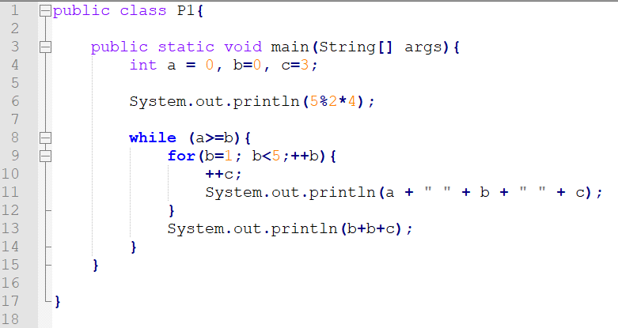

|  |  |  |  |
| --- | --- | --- | --- |
| **a** | **b** | **c** | **Output** |
|  |  |  |  |
|  |  |  |  |
|  |  |  |  |
|  |  |  |  |
|  |  |  |  |
|  |  |  |  |
|  |  |  |  |

1. What is the difference in output between lines 11 and 13?
2. How many times is the **for** loop executed? Why?
3. How many times is the **while** loop executed? Why?
4. What does line 10 do?
5. What is the control variable for each loop in the program?

**Problem #2**

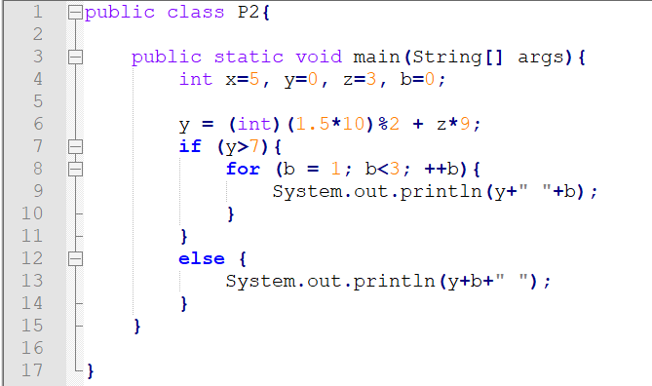

|  |  |  |  |  |
| --- | --- | --- | --- | --- |
| **b** | **x** | **y** | **z** | **Output** |
|  |  |  |  |  |
|  |  |  |  |  |
|  |  |  |  |  |
|  |  |  |  |  |
|  |  |  |  |  |
|  |  |  |  |  |
|  |  |  |  |  |

1. Are there any errors in the code above?
2. What is the final value of variable y?
3. What is the difference between the output generated by lines 9 and 13?
4. How many times is the **for** loop executed?
5. Where is the **casting** being performed in the code above? And what is the purpose of it?

Problem #3

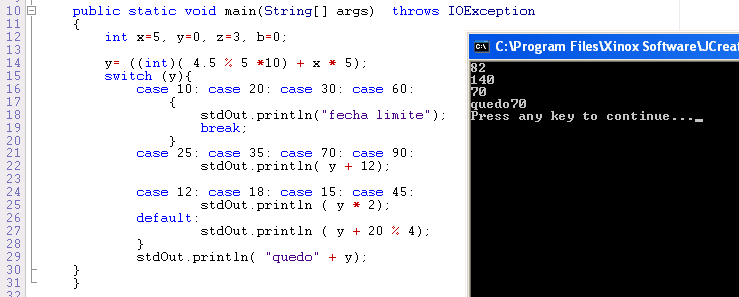

1. What does line 14 do?
2. Which braces { } can be considered optional in the code above? Why?
3. Are there any errors in the code above?
4. What do you have to keep in mind when using a **switch** statement?
5. List two advantages of using a **switch** offer an **if** in the code above.

**Problema 4:** At the beginning of 2024, Tesla Motors opened their first dealership in Monterrey. They sell only one car model: Tesla Model 3 in two configurations: basic and equipped. To pay for the car, they offer two payment schemes: pay in cash or finance the car.

If the person decides to pay in cash, they get a 10% discount on the basic car and a 15% discount on the equipped mode. If the buyer decides to finance the car, it will be deferred in 48 monthly installments, with a 25% increment to the price of the car.

Build a program that can calculate the total payment a client will do depending on the type of car they chose and their payment type. If the buyer wants to finance the car, show the monthly payment too.

**Problem 5:** A student writes and sells English essays for money. His rates are calculated in the following way:

* $120.00 for the first 3 pages
* $30.00 for each additional page
* If the essay is longer than 10 pages, he will charge an extra $25.00

**Problema 5.** Un estudiante vende monografías por una cierta cantidad de dinero a fin de tener una mayor holgura económica. Los honorarios van en función del número de páginas de cada documento y las tarifas son:

• $120.00 de tarifa mínima para trabajos de una a tres páginas

• $30.00 por cada página adicional

• Un importe complementario de $25.00 si el número de páginas excede de 10.

Si suponemos que cada página admite 400 palabras a un espacio, una monografía de 2,600 palabras equivaldría a unos honorarios de $240,00. Es decir, 2,600 / 400 = 6.5 páginas, que el estudiante cobra como 7 páginas enteras. El cálculo es de 120,00 (para las primeras 3 páginas) + 30 x 4 páginas (7 - 3) lo que da un importe a cobrar de $240.00.

(a) Calcule los honorarios, mostrando todos los pasos, para las monografías de las siguientes extensiones:

(i) 1,000 palabras

(ii) 3,975 palabras

**Problema 6.** Construye un programa para ayudar al estudiante a calcular sus honorarios. El código tiene que pedirle al estudiante que ingrese el número de palabras de la monografía.

La salida que se desea será:

* Número real de páginas
* Número de páginas que se cobrarán
* Los honorarios por la mecanografía.